Project Planning Phase
Project Planning Template (Product Backlog, Sprint Planning, Stories, Story Points)
Date | 27 September 2026
Team ID | [SWTID-2026-9584]
Project Name | Streamlining IT Procurement: Automating Standard Laptop Orders with Flow Designer
Maximum Marks | 5 Marks

Product Backlog, Sprint Schedule, and Estimation (4 Marks)
The product backlog below breaks each Epic into user stories, estimated in story points and scheduled across two sprints:
Sprint | Functional Requirement (Epic) | USN | User Story / Task | Story Points | Priority | Team Members
Sprint-1 | Laptop Request Submission | USN-1 | As an employee, I can submit a standard laptop request through the Service Catalog so that I don't have to email IT manually. | 3 | High | TM-2 (ServiceNow Dev), TM-3 (Business Analyst)
Sprint-1 |  | USN-2 | As an employee, I want my department and manager fields auto-filled from my profile so that I don't enter them manually. | 2 | Medium | TM-2 (ServiceNow Dev)
Sprint-2 | Status Tracking & Notifications | USN-3 | As an employee, I receive an email once my laptop is configured and ready for pickup so that I know when to collect it. | 2 | High | TM-2 (ServiceNow Dev)
Sprint-1 | Approval Workflow | USN-4 | As a manager, I can approve or reject a laptop request from my ServiceNow inbox so that I don't need a separate ticket. | 2 | High | TM-2 (ServiceNow Dev)
Sprint-2 |  | USN-5 | As a manager, I can add a rejection reason so the requester understands why the request was declined. | 1 | Medium | TM-2 (ServiceNow Dev)
Sprint-2 | Status Tracking & Notifications | USN-6 | As an IT procurement team member, I can view a dashboard of all pending / in-progress laptop requests to track turnaround. | 5 | Medium | TM-3 (Business Analyst)
Sprint-1 | Automated Task Creation & Assignment | USN-7 | As an IT procurement team member, I don't have to manually create a hardware task once a request is approved — it happens automatically. | 2 | High | TM-1 (IT Procurement Lead), TM-2 (ServiceNow Dev)
Sprint-1 |  | USN-8 | As a Hardware team member, I automatically receive a configuration task assigned to my group as soon as a request is approved. | 5 | High | TM-2 (ServiceNow Dev), TM-4 (Hardware Rep)
Sprint-1 |  | USN-9 | As a Hardware team member, I can close the task once configured, which auto-updates the request and notifies the requester. | 5 | High | TM-2 (ServiceNow Dev), TM-4 (Hardware Rep)
Sprint-2 |  | USN-10 | As a Hardware team member, I receive an escalation alert if I haven't started a task within 4 hours so that SLAs aren't missed. | 3 | Medium | TM-2 (ServiceNow Dev)

Project Tracker, Velocity & Burndown Chart (4 Marks)
Sprint | Total Story Points | Duration | Sprint Start Date (Planned) | Sprint End Date (Planned) | Story Points Completed | Sprint Release Date (Actual)
Sprint-1 | 19 | 6 Days | 28 Sep 2026 | 03 Oct 2026
Sprint-2 | 11 | 6 Days | 05 Oct 2026 | 10 Oct 2026

Velocity:
Velocity is the number of story points a team completes in a sprint. Average Velocity (AV), in points per day, is calculated as:
AV = Velocity ÷ Sprint Duration
For this project's Sprint-1: Velocity = 19 story points, Sprint Duration = 6 days, so AV = 19 ÷ 6 ≈ 3.2 story points per day. This gives the team a baseline to forecast Sprint-2 and beyond.
Burndown Chart:
A burndown chart plots remaining work against time, making it easy to see whether a sprint is on track. The planned (ideal) burndown for Sprint-1 is shown below; actual progress can be plotted against it once the sprint is underway.
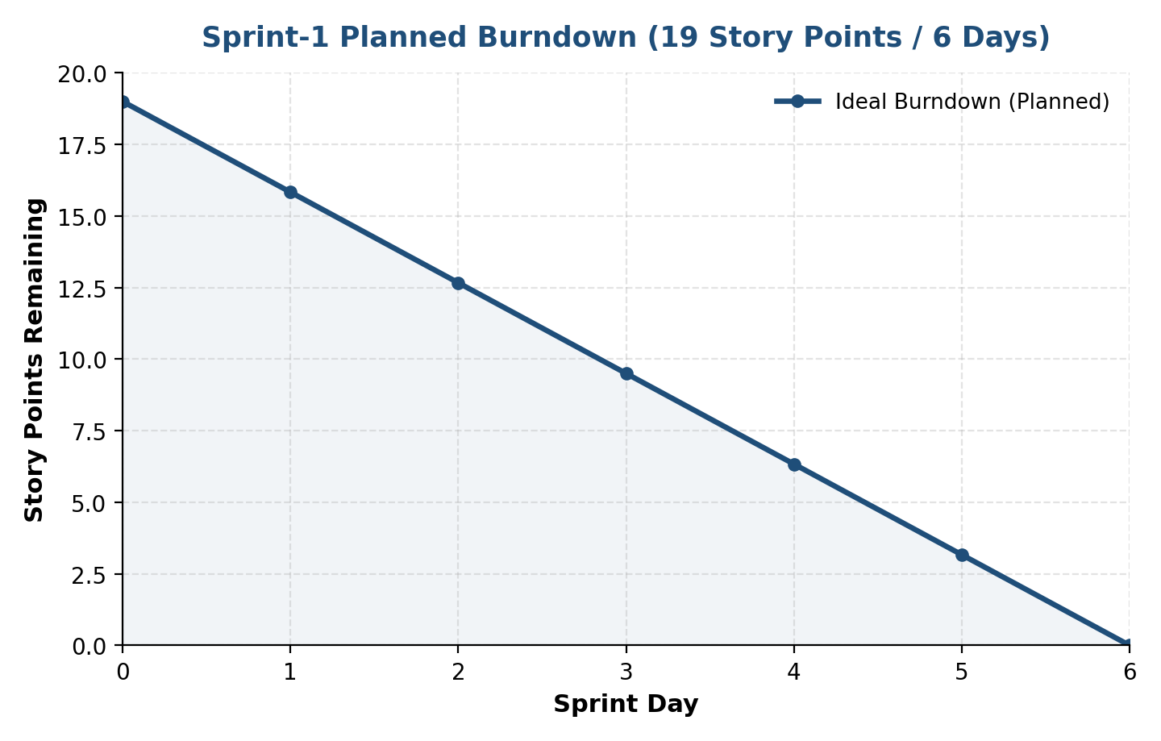

References
https://www.atlassian.com/agile/project-management
https://www.atlassian.com/agile/tutorials/epics
https://www.atlassian.com/agile/tutorials/sprints
https://www.atlassian.com/agile/project-management/estimation
https://www.atlassian.com/agile/tutorials/burndown-charts
https://www.visual-paradigm.com/scrum/scrum-burndown-chart/

